**People’s Democratic Republic of Algeria**

**Houch El Mihoub-3- Middle School**

**Level : 4MS Timming : 1h 30 min**

First Term Exam

**Text:**

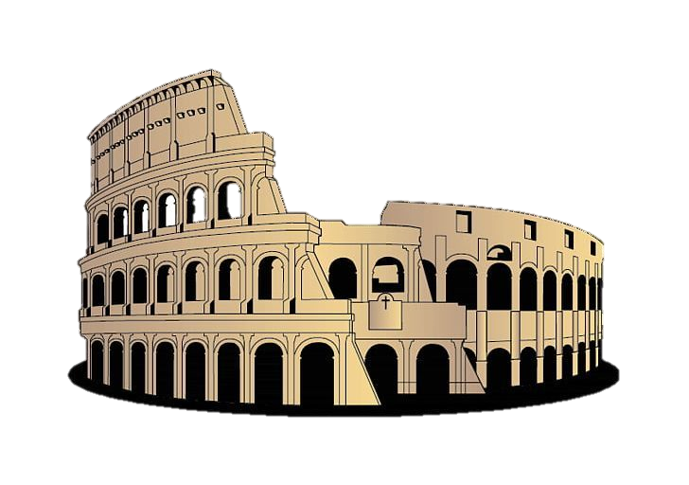 Last August, I went to Rome with my friend Peter. We booked a flight **there** with British Airways. We stayed for a week in a small hotel near the Colloseum. The hotel was nice and pretty cheap.

During the day, we walked around the city .**We** saw all the famous places like the Colloseum and St Peter’s, and we threw a coin in the Trevi Fountain to make a wish .We took a lot of photos. At night, we went to restaurants and had fantastic pasta and Pizzas. Our favourite restaurant was the ‘Piazza Navona’.

We bought the painting of Trastevere (the old town) as a souvenir and Peter bought some presents for his family . We had a great time. Rome is full of history and has a special atmosphere, and Italian food is delicious. We only had two problems: it was hot, and it was very difficult to cross the road.

What about you? Did you go somewhere?

**Part one**

**A/Reading Comprehension**

Activity 01: Read the text and say ‘True’ , ‘False’ or ‘ Not mentioned’ (03pts)

1. Peter and his friend travelled by plane. (…………………….)
2. The flight lasted for two hours. (……………………..)
3. They stayed at a friend’s house. (……………………..)

Activity 02: Read the text and answer the questions (02pts)

1. What or who do the words in bold type refer to:

**there**🡺 …………………………  **we** 🡺………………………………..

1. Did Peter and his friend buy souvenirs?

………………………………………………………………………………….

Activity 03: Find in the text : (02pts)

1. Synonyms to:

Well-known = ………………….. (§2) Fantastic = …………..………… (§ 3)

1. Opposites to:

Far ≠……………………….. (§1) Easy ≠ ………………………. (§3)

**B/Mastery of Language**

Activity 01: Use the comparative of equality ‘as…as’ or inequality ‘not as…as’: (03pts)

1. China / India ( = populated )

………………..…………………………………………..

1. The Pyramids of Giza / Big Ben ( ≠ attractive )

…………………………………...………………………..

1. William Shakespeare / Pablo Picasso ( = famous )

…………………………………………………………….

Activity 02: Rewrite the sentences differently: (02pts)

1. Mark wanted to see the Eiffel Tower, so he travelled to Paris.

* Because ……………………………………………………..

1. The Mona Lisa was painted by Leonardo Da Vinci.

* Leonardo Da Vinci ………………………………………….

Activity 03: Classify the words according to the pronunciation of their final ‘-ed’: (02pts)

Populated - Blamed - Decided - Finished

|  |  |  |
| --- | --- | --- |
| **/ t /** | **/ d /** | **/ id /** |
|  |  |  |

**Part two**

Situation of Integration: (06pts)

You received a letter from your friend. She/he told you about her/his holidays. She/he would like to know where did you travel to, in your last summer holidays. Write her/him a letter in which you tell her/him about your trip itinerary.

 Write about:

- The place you went to (abroad/another town/or stayed at home)

- How did you travel ( by plane/ by car/ by train ……etc)

- What you did (your activities during the holidays)

- How much time did you spend there ( a week, a month,…..)

- Your feelings ( was it great ?/ was it horrible?)

****………………………………………………………………………………………………………………………………………………………………………………………………………………………………………………………………………………………………………………………………………………………………………………………………………………………………………………………………………………………………………………………………………………………………………………………………………………………………………………………………………………………………………………………………………………………………………………………………………………………………………………………………………………………………………………………………………………………………………………………………

Good Luck